
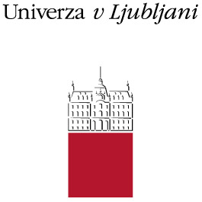

ERASMUS+ (STT)
Letter of confirmation for Erasmus+ Staff Training Mobility
in the Academic Year 2017/18

We hereby confirm that the below mentioned person from the University of Ljubljana (Erasmus code: SI LJUBLJA 01), successfully accomplished Erasmus Staff Training Mobility, agreed in her/his Work Plan.
Name and surname of the person:

Name and address of host institution:

E-mail of contact person:

Erasmus code of host institution:

Dates of mobility period /day/month/year/ from : till:

Total number of working days: _______________ days

Performed activities at the host institution:

Gained experiences during the staff training:

Confirmation of the host institution:

Name of responsible person and signature:

_______________________________________________ Stamp:
Position of responsible person at the host institution:

_______________________________________________ Date:

